

International School

**Capstone Project 1**

CMU-CS450

**Test Plan Document**

**Version 1.4**

**Date:** 08/11/2022

**Craft Village Pollution Monitor System**

**Submitted by**

**Ca, Van Cong Le**

**Huy, Bui Duc**

**Phuc, Hua Hoang**

**Trung, Nguyen Thanh**

**Approved by**

**Ph.D. Nguyen Thanh Binh**

**Proposal Review Panel Representative:**

Name Signature Date

**Capstone Project 1 - Mentor:**

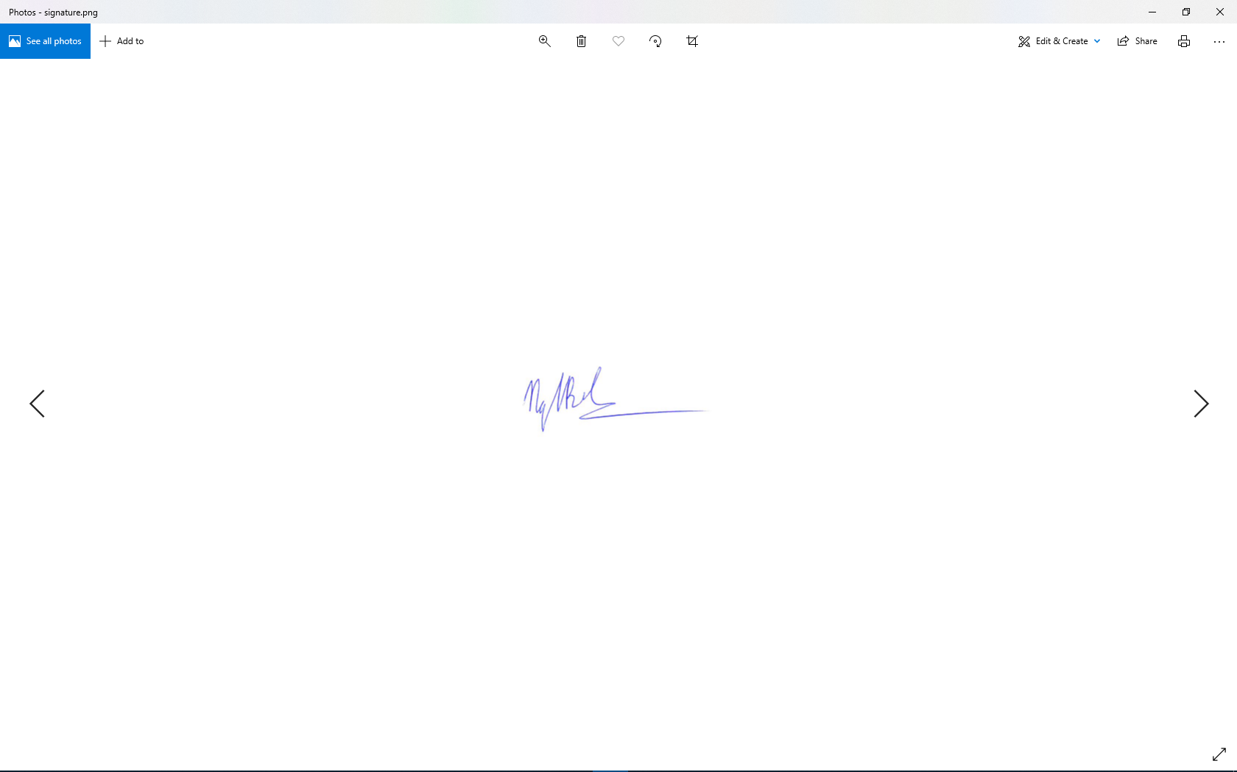

Name Signature Date

**PROJECT INFORMATION**

|  |  |  |  |
| --- | --- | --- | --- |
| **Project acronym** | CVPMS | | |
| **Project Title** | Craft Village Pollution Monitor System | | |
| **Start Date** | 22/08/2022 | **End Date** | 07/12/2022 |
| **Lead Institution** | International School, Duy Tan University | | |
| **Project Mentor** | Ph.D. Thanh Binh, Nguyen | | |
| **Scrum master / Project Leader & contact details** | Ca, Van Cong Le  *Email:* cascabusiness@gmail.com  *Tel:* 0352707895 | | |
| **Partner Organization** |  | | |
| **Project Web URL** | [*https://github.com/Casca113s2/craft-village-pollution-monitor-system*](https://github.com/Casca113s2/craft-village-pollution-monitor-system) | | |
| **Team members** | **Name** | **Email** | **Tel** |
| 25211207666 | Ca, Van Cong Le | [cascabusiness@gmail.com](http://cascabusiness@gmail.com) | 0352707895 |
| 25211215894 | Huy, Bui Duc | [duchuyltt122@gmail.com](http://duchuyltt122@gmail.com) | 0818648090 |
| 25211204084 | Phuc, Hua Hoang | [phuchuho0402@gmail.com](http://phuchuho0402@gmail.com) | 0905639682 |
| 25211215133 | Trung, Nguyen Thanh | [nguyenttrung2601@gmail.com](http://nguyenttrung2601@gmail.com) | 0774496838 |

DOCUMENT NAME

|  |  |  |  |
| --- | --- | --- | --- |
| **Document Title** | Test Plan Document | | |
| **Author(s)** | Van Cong Le Ca  Hua Hoang Phuc  Nguyen Thanh Trung | | |
| **Date** | 08/11/2022 | **File Name** | C1SE.06_CVPMS_Test-Plan-Document_v1.4.docx |

REVISION HISTORY

| **Version** | **Date** | **Comments** | **Author** | **Approval** |
| --- | --- | --- | --- | --- |
| 1.0 | 01/09/2022 | Create Test Plan Document | Van Cong Le Ca  Hua Hoang Phuc  Nguyen Thanh Trung |  |
| 1.1 | 18/09/2022 | Update Test Plan for Sprint 2 | Van Cong Le Ca  Hua Hoang Phuc Nguyen Thanh Trung |  |
| 1.2 | 05/10/2022 | Update Test Plan for Sprint 3 | Van Cong Le Ca  Hua Hoang Phuc  Nguyen Thanh Trung |  |
| 1.3 | 22/10/2022 | Update Test Plan for Sprint 4 | Van Cong Le Ca  Hua Hoang Phuc  Nguyen Thanh Trung |  |
| 1.4 | 08/11/2022 | Update Test Plan for Sprint 5 | Van Cong Le Ca  Hua Hoang Phuc  Nguyen Thanh Trung |  |

**Approve Document:** Sign in to approve the document

|  |  |  |  |
| --- | --- | --- | --- |
| **Mentor** | Binh, Nguyen Thanh | Date | 08/11/2022 |
| Sign |  |
| **Scrum Master** | Ca, Van Cong Le | Date | 08/11/2022 |
| Sign |  |
| **Scrum Member** | Huy, Bui Duc | Date | 08/11/2022 |
| Sign |  |
| **Scrum Member** | Phuc, Hua Hoang | Date | 08/11/2022 |
| Sign |  |
| **Scrum Member** | Trung, Nguyen Thanh | Date | 08/11/2022 |
| Sign |  |

Table Of Contents

1. Introduction 6

1.1. Purpose 6

1.2. Scope 6

1.3. Out Of Scope 6

1.4. Reference 7

1.5. Risk List 7

2. Test Specification 9

2.1. Test Items 9

2.2. Test Deliverables 10

2.3. Test Strategy 11

2.4. Tools 11

2.5. Resource 12

3. Test Cycle and Exit Criteria 12

3.1. Entry Criteria 12

3.2. Exit Criteria 12

4. Test Milestones 13

**Table Of Tables**

**Table 1.** Reference documents 7

**Table 2.** Risk List 7

**Table 3.** Test Items 9

**Table 4.** Test Strategy 11

**Table 5**. Tools 11

**Table 6.** Resources 12

**Table 7.** Test milestones 13

# Introduction

A test plan is a detailed software verification document that provides specifics on how the validate will test all aspects of software design. Test plans are test specifications used as guides for writing test case suites for design validation in both the software engineering fields. This test plan document contains a description of product functionality, a description of test cases to be written for each function, and a description of the testing platform to be used.

## Purpose

The purpose of the Test Plan is to define, schedule and monitor the test execution. It supports the following objectives:

* Provide a high-level list of the major target test functions.
* List the Requirements for testing.
* Describe the testing strategies to be employed on each target test functions.
* Identify the required resources and schedule the Test execution.

## Scope

This Test Plan is for release test plan for viBOTour system. The Test Plan defines the unit, integration and system testing approach. The test scope includes the following:

* Testing of all functions.
* Application performance.
* Use cases requirements listed in the Product Backlog and User Stories document.

## Out Of Scope

The following is considered out of scope for Craft Village Pollution Monitor System Test Plan and testing scope: Performance testing for Craft Village Pollution Monitor System.

## Reference

**Table 1.** Reference documents

|  |  |  |
| --- | --- | --- |
| **No** | **Document references** | **Document Information** |
| 01 | Proposal document | C1SE.06_CVPMS_Project-Proposal-Document_v1.0.docx |
| 02 | Product Backlog and User Story document | C1SE.06_CVPMS_ProductBacklog-Userstory-SprintBacklog.xlsx |
| 03 | Project Plan Document | C1SE.06_CVPMS_Project-Plan_v1.0.docx |

## Risk List

**Table 2.** Risk List

|  |  |  |  |
| --- | --- | --- | --- |
| **Risk** | **Mitigation Strategy** | **Responsibility** | **Contingency (Risk is realized)** |
| External Risks | Get fewer projects but will definitely succeed or have a high success rate | Not under control of the Project Team or Project Steering Group | Do your part, recognize and eliminate risks as soon as possible |
| Project Management | Agree on all the standards before starting the project | Leader | It is mandatory to revise the whole project to the original standard if it is not correct |
| Tester | Sick, busy or crash cannot do it | Team tester | self-supplementing undo their assigned work, the way other members are supposed to support |
| Technology | Technology analysis before starting each project | Tester | Exchange learning in groups |
| Tester Skill | Train, or recruit experienced people | Tester, Team leader | Train technology professionals or invite professors to help with the project |
| Estimate Plan | Calculate carefully and accurately when taking requests and analyzing, apply good models and methods for estimation | Request Collectors, Request Analyst | Enlist the product delivery time or overtime for timely delivery |
| Automation Tool Risks | Choose the right tools and quality, check the tools before starting the project | Tester, Team leader | Exchange in groups, change new tools and remove inconsistent tools |
| Out of system scope | Analyze and find solutions to test all testable areas | Tester |  |

# Test Specification

## Test Items

**Table 3.** Test Items

*\* The following list describes the features that will be tested*

*\*\* Team acronym – F: Function*

|  |  |  |  |  |  |
| --- | --- | --- | --- | --- | --- |
| **ID** | **Function** | **A part of** | **Priority** | **Type Test case** | **Note** |
| FE01 | Login | PB02 | H | User interface, Functionality,  Usability |  |
| FE02 | Register | PB01 | H | User interface, Functionality,  Usability |  |
| FE03 | Forgot Password | PB04 | M | User interface, Functionality,  Usability |  |
| FE04 | Change Password | PB07 | M | User interface, Functionality,  Usability |  |
| FE05 | Send Mail | PB01, PB07 | M | User interface, Functionality,  Usability |  |
| FE06 | Edit User’s Information | PB05 | L | User interface, Functionality,  Usability |  |
| FE07 | Change Language | PB11 | L | User interface, Functionality,  Usability |  |
| FE08 | Take Pollution Photo | PB08 | H | User interface, Functionality,  Usability |  |
| FE09 | Detect Location | PB08 | H | User interface, Functionality,  Usability |  |
| FE10 | Auto Fill Information | PB08 | H | User interface, Functionality,  Usability |  |
| FE11 | Add New Village | PB08 | H | User interface, Functionality,  Usability |  |
| FE12 | Detection Pollution Types | PB08 | H | User interface, Functionality,  Usability |  |
| FE13 | Add Additional Information | PB08 | H | User interface, Functionality,  Usability |  |
| FE14 | Submit Survey | PB08 | H | User interface, Functionality,  Usability |  |
| FE15 | View Finished Survey | PB12 | M | User interface, Functionality,  Usability |  |
| FE16 | View In Progress Survey | PB12 | M | User interface, Functionality,  Usability |  |
| FE17 | Accept/Decline New Village | PB10 | H | User interface, Functionality,  Usability |  |
| FE18 | Create Local Authority Account | PB06 | H | User interface, Functionality,  Usability |  |
| FE19 | Display Dashboard | PB14 | H | User interface, Functionality,  Usability |  |

## Test Deliverables

* Test Plan Document.
* Test Case Document.
* Test Summary Report.

## Test Strategy

**Table 4.** Test Strategy

|  |  |  |  |
| --- | --- | --- | --- |
| **Test Types** | **Test Stages** | | |
| **Unit** | **Integration** | **Acceptance** |
| Functional Tests | X | X | X |
| User Interface | X | X | X |
| Reliability   * Integrity * Structure | X | X |  |

## Tools

**Table 5**. Tools

|  |  |  |  |
| --- | --- | --- | --- |
| **Purpose** | **Tool** | **Vendor** | **Version** |
| Microsoft Excel is used to write Test Plan and Test Cases. | Microsoft Excel | Microsoft | 2016 |
| Katalon Platform is an automation testing software tool developed by Katalon, Inc. The software is built on top of the [open-source](https://en.wikipedia.org/wiki/Open-source_software) automation frameworks [Selenium](https://en.wikipedia.org/wiki/Selenium_(software)), [Appium](https://en.wikipedia.org/wiki/Appium) with a specialized [IDE](https://en.wikipedia.org/wiki/Integrated_development_environment) interface for [Web](https://en.wikipedia.org/wiki/Web_testing), [API](https://en.wikipedia.org/wiki/API_testing), [mobile](https://en.wikipedia.org/wiki/Mobile_application_testing) and desktop application testing. | Katalon | Katalon Studio | 8.5.2 |

## Resource

**Table 6.** Resources

|  |  |  |
| --- | --- | --- |
| **The role** | **Resource** | **Specific responsibilities** |
| Tester | All members | Executes the tests. Responsibilities include:   * Execute test suites * Log results * Analyze and recover from test failures * Document incidents |
| Testing System | All members | Ensures test environments are managed and maintained.  Responsibilities include:   * Administer test management system. * Install and support access to, and recovery of, test environment configurations and test labs. |

# Test Cycle and Exit Criteria

## Entry Criteria

* + - All test hardware platforms must have been successfully installed, configured, and functioning properly.
    - All the necessary documentation, design, and requirements information should be available that will allow testers to operate the system and judge the correct behavior.
    - Proper test case is available.
    - The test environment such as, lab, hardware, software, and system administration support should be ready.

## Exit Criteria

* + - All test cases have been run.
    - A certain level of requirements coverage has been achieved.
    - No high priority or severe bugs are left outstanding.
    - All high-risk areas have been fully tested, with only minor residual risks left outstanding.
    - The schedule has been achieved.
    - Not over the allowed project budget

# Test Milestones

**Table 7.** Test milestones

|  |  |  |  |
| --- | --- | --- | --- |
| **Milestone Task** | **Name** | **Date Start** | **Date Finish** |
| Test Plan | Test Plan Document | 17/08/2022 | 17/08/2022 |
| Test plan and test case for Sprint 1 | Test plan and test case for Sprint 1 | 01/09/2022 | 01/09/2022 |
| Test plan and test case for Sprint 2 | Test plan and test case for Sprint 2 | 18/09/2022 | 18/09/2022 |
| Test plan and test case for Sprint 3 | Test plan and test case for Sprint 3 | 05/10/2022 | 05/10/2022 |
| Test plan and test case for Sprint 4 | Test plan and test case for Sprint 4 | 22/10/2022 | 22/10/2022 |
| Test plan and test case for Sprint 5 | Test plan and test case for Sprint 5 | 08/11/2022 | 08/11/2022 |